**Divya Kulkarni (001543678) SEC -01**

**Program Structures & Algorithms**

**Spring 2021**

**Assignment No. 3**

**Task: Union Find Height Weighted Quick Union with Path Compression**

**Output/Observations:**

Sample Runs generated for fixed set of n values:

|  |  |  |  |
| --- | --- | --- | --- |
| **No. Of Objects** | **No. of Pairs Generated** | **No. of Times Union Performed (n-1)** |  |
| 10 | 14 | 9 |  |
| 100 | 294 | 99 |  |
| 1000 | 2982 | 999 |  |
| 2000 | 10089 | 1999 |  |
| 5000 | 20507 | 4999 |  |
| 8000 | 41567 | 7999 |  |
| 10000 | 49269 | 9999 |  |
| 20000 | 101975 | 19999 |  |
| 30000 | 174538 | 29999 |  |
| 40000 | 226832 | 39999 |  |
| 50000 | 280694 | 49 |  |

**Some Random Captured Sample Outputs:**

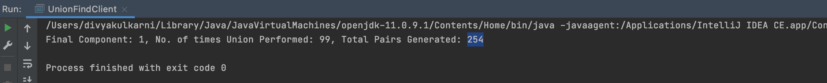

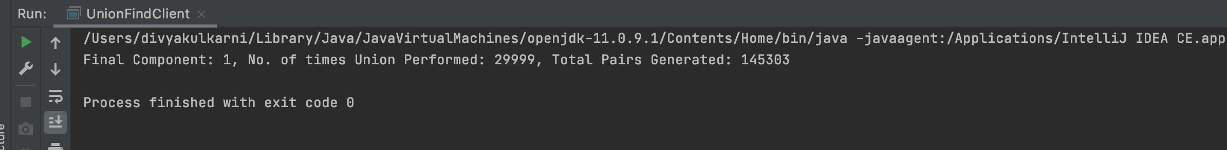

**Relationship Conclusion:**

In order to get only one component at the end, there were. number of experiments performed on the fixed set of values of n. It takes liner time to initialize the data structure. After performing union, find, and connected operations it takes **logarithmic amortized time**.

**Test Cases Passed:**

